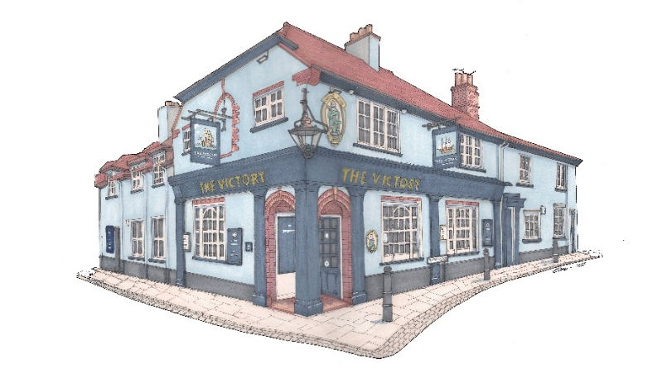
www.victorywalton.co.uk
Starters:
Beef carpaccio, parmesan, watercress. (GF) £9
Duck rillette & apricot jam, toast £9
Sautéed king prawns, garlic butter. (GF) £9
Deep fried whitebait £9
Sauté wild mushroom & garlic crostini £9
Smoked salmon, sesame, soy dressing. (GF) £9
Tomato, ginger, chilli & coriander soup (V)(GF) £9
New Zealand green lipped mussels, coconut & coriander £9/£16 To share – Hummus, flat bread, tzatziki, olives. (V) £14

Sunday Roast *
Roast 28 day aged Sirloin/Ribeye £25
Roast rump of English lamb £20
Rare breed roast topside of beef £20
Roast loin of Kilravock pork, braeburn apple. £20
Children’s Roast (beef, pork or lamb) £10

Mains:
BBQ ribs, fries & red cabbage coleslaw (GF) £20
Beer battered line caught north Atlantic cod fillet, house cut chips, pea puree, tartare. * £20
Salmon & dill fishcakes, coleslaw & fries. (GF) £19
Pea & mint risotto, watercress & parsnip crisps. (V) £19
Cumberland sausage & mash, red onion gravy £17

Desserts: (All Homemade)
Seasonal crumble, vanilla ice cream or custard * £9
Sticky toffee pudding, salted caramel ice-cream, toffee sauce £9
Homemade cheesecake (GF) £9
Trio of ice-cream or Sorbet (GF) £9
Seasonal trifle £9
Triple chocolate brownie, vanilla ice cream (GF) £9
A selection of English & Continental cheeses, water biscuits, and chutney. (Port) £12
Please advise your server of any food allergies or intolerances. * Gluten free option available *

